Water Jug Problem

AIM
To write a Python program to solve the Water Jug Problem using Breadth-First Search (BFS) and find the sequence of steps required to obtain the target amount of water.

ALGORITHM
- Start with both jugs empty.
- Define the capacities of Jug 1 and Jug 2 and the target amount.
- Represent each state as (Jug1, Jug2).
- Use a queue to perform Breadth-First Search.
- From each state, perform the following operations:
- Fill Jug 1.
- Fill Jug 2.
- Empty Jug 1.
- Empty Jug 2.
- Pour Jug 1 into Jug 2.
- Pour Jug 2 into Jug 1.
- Store visited states to avoid repetition.
- Continue until the target amount is obtained in either jug.
- Display the sequence of states as the solution path.

CODE
from collections import deque

def water_jug(jug1, jug2, target):
visited = set()
queue = deque()

queue.append(((0, 0), []))

while queue:
(a, b), path = queue.popleft()

if (a, b) in visited:
continue

visited.add((a, b))
path = path + [(a, b)]

if a == target or b == target:
print("Solution Path:")
for state in path:
print(state)
return

states = [
(jug1, b),
(a, jug2),
(0, b),
(a, 0),
(a - min(a, jug2 - b),
b + min(a, jug2 - b)),
(a + min(b, jug1 - a),
b - min(b, jug1 - a))
]
for state in states:
if state not in visited:
queue.append((state, path))
print("No solution exists.")
jug1 = 4
jug2 = 3
target = 2
water_jug(jug1, jug2, target)

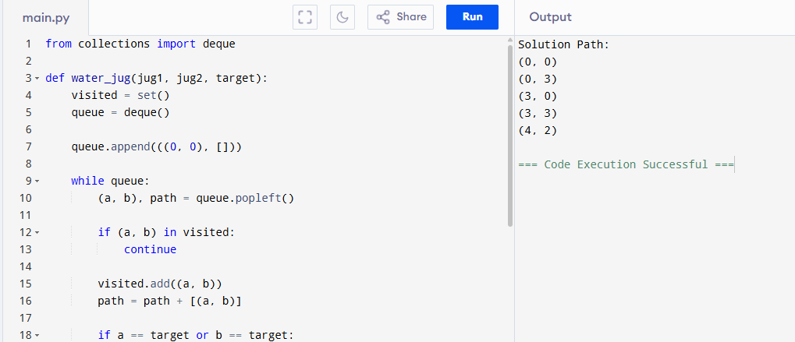

RESULT
Thus, the Water Jug Problem was successfully solved using Python and the required target amount was obtained.

Crypt-Arithmetic Problem

AIM
To write a Python program to solve the Crypt-Arithmetic problem using backtracking and permutations.

ALGORITHM
- Identify all unique letters in the given words.
- Assign a unique digit from 0 to 9 to each letter.
- Ensure that the first letters S and M are not zero.
- Generate possible digit combinations using permutations.
- Substitute the digits for the corresponding letters.
- Calculate the numerical values of SEND, MORE, and MONEY.
- Check whether SEND + MORE = MONEY.
- If the equation is satisfied, display the letter-to-digit mapping and solution.

CODE
from itertools import permutations

def solve_cryptarithm():
letters = "SENDMORY"

for perm in permutations(range(10), len(letters)):
s, e, n, d, m, o, r, y = perm

# First letters cannot be zero
if s == 0 or m == 0:
continue

send = 1000*s + 100*e + 10*n + d
more = 1000*m + 100*o + 10*r + e
money = 10000*m + 1000*o + 100*n + 10*e + y

if send + more == money:
print("Solution:")
print("S =", s)
print("E =", e)
print("N =", n)
print("D =", d)
print("M =", m)
print("O =", o)
print("R =", r)
print("Y =", y)

print("\n", send)
print("+", more)
print("------")
print(money)
break

solve_cryptarithm()
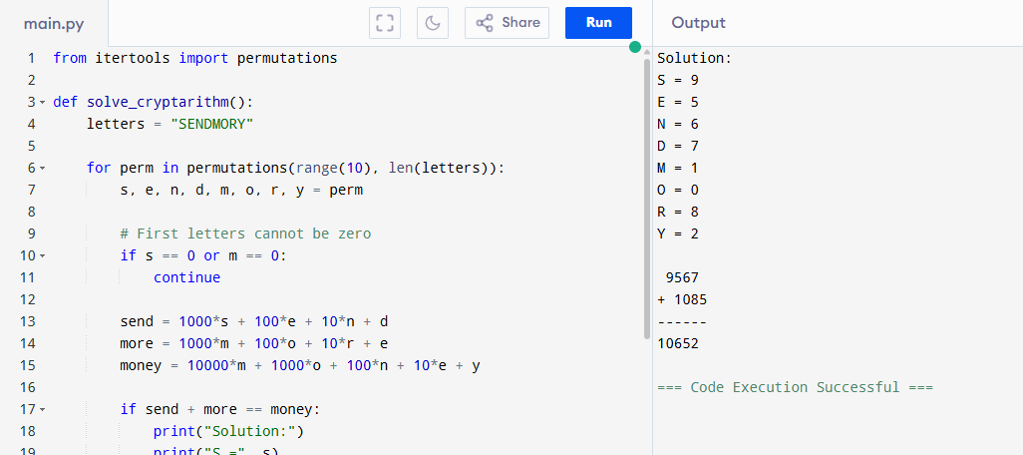

RESULT
Thus, the Crypt-Arithmetic problem was successfully solved using Python.

